



**MYSQL END OF MODULE CHALLENGE ANSWERSHEET**

|  |  |
| --- | --- |
| **Assessor** | Godwin |
| **Moderator** | Alex |
| **Due Date** | 16 November 2021 |
| **PASS MARK** | 50% |
| **Student Name** | Manicia Theron |

**INSTRUCTIONS**

1. Please adhere to the due dates.

2. Coping/Plagiarism is not accepted.

3. Make sure you write the code in the space provided for each question

4. Upload the Answersheet together with the database dump (backup file)

**1. CREATING DATABASE AND MANIPULATING DATA**

A local shop owner has asked you to design a database which they will use to store information about their suppliers and the products they supply. They sell fresh produce to the public. They provided you with a list of their suppliers and the products they supply to help you design the database. The database consists of TWO tables (*Suppliers* and *Products*).

1.1 Database Creation. Paste you code in the space provided. **[3]**

CREATE DATABASE FruitMarket;

1.2 Table Suppliers. Paste you code in the space provided. **[8]**

CREATE table Supplier(SupplierID INT(10) PRIMARY KEY,CompanyName VARCHAR(30) NOT NULL,ContactPerson VARCHAR(30) NOT NULL,ContactNo INT(15) NOT NULL DEFAULT 0,ProdutCategory VARCHAR(55) NOT NULL);

3 marks for correct SQL statements

5Marks for correct field-names and keys as stated above

1.3 Products table using details provided below.

**Solution**

Write your code on the space provided in the space provided below. [4]

CREATE table Products(ProductId INT(10) PRIMARY KEY,ProductName VARCHAR(30) NOT NULL,Price INT(30) DEFAULT 0.00,Weight INT(15) NOT NULL DEFAULT 0,Stock VARCHAR(55) NOT NULL,SupplierID INT(10) NOT NULL);

1 Mark for correct SQL and table

2 Marks for correct field-names and sizes, deduct 1 mark for wrong fields sizes and 1 mark for data types

1 mark for correct linking of the foreign key

1.4 Relationship [1]

One-to-many

1.5

Foreign key [1]

SupplierId

1.6 Adding records to the database. [1]

Write your answer in the space provided in the space provided.

INSERT INTO Supplier (SupplierID, CompanyName, ContactPerson, ContactNo, ProductCategory) values ('SUPP0001', 'Fruit City', 'Themba', '0115062089', 'Fruit'), ('SUPP0002', 'Vegan Veggie Express', 'Chinyere', '0137228936', 'Vegetables'),('SUPP0003', 'The Nut House', 'Sam', '0216965113', 'Nuts'),('SUPP0004', 'The Lazy Cow', 'Angelo', '0216964157', 'Dairy');

1 Marks for each correct record

Deduct 1 Mark if a single insert is not used

1.7 Add records into the Products table. Write your answer in the space provided. [4]

USE FruitMarket;

INSERT INTO Products (ProductId,ProductName,Price,Weight,Stock,SupplierID)

values ('1001','Lady Finger Bananas','17.95','750 g','45','SUPP0001'),

('1002','Pink Lady Apples','18.95','1.5 kg','15','SUPP0001'),

('1003','Red Anjou Pears','22.99','1 kg','24','SUPP0001'),

('1004','Cavendish Bananas','12.65','900 g','18','SUPP0001'),

('2001','Tenderstem Broccoli','35.90','400 g','8','SUPP0002'),

('2002','Portabellini Mushrooms','18.99','250 g','16','SUPP0002'),

('3001','Raw Almonds','99.00','1 kg','6','SUPP0003'),

('3002','Macaroon Butter','32.95','410 g','9','SUPP0003'),

('3003','Organic Coconut Oil','89.95','500 ml','15','SUPP0003'),

('4001','Ayrshire Milk','33.95','3 l','23','SUPP0004'),

('4002','Simonzola Blue Cheese','27.65','270 g','4','SUPP0004');

4 Marks for adding all the records correctly

Deduct 1 mark if a record is missing. Maximum of 2 marks

1.8 SQL query to extract the following ProductId, ProductName, Price, Weight, Stock, ProductCategory [6]

USE FruitMarket;

CREATE VIEW QueryExtract AS

SELECT Products.ProductID, ProductName, Price,Weight,Stock, Supplier.ProductCategory

FROM Products

INNER JOIN Supplier

ON Products.SupplierID = Supplier.SupplierID

WHERE Stock < 20

ORDER BY Products.Price DESC;

2 marks for correct SQL statement

Maximum of 2 marks for correct fields.

1 mark for the order

1 mark for permanently saving into the database

1.9 View Q1.9 [6]

Your Output in the space below:

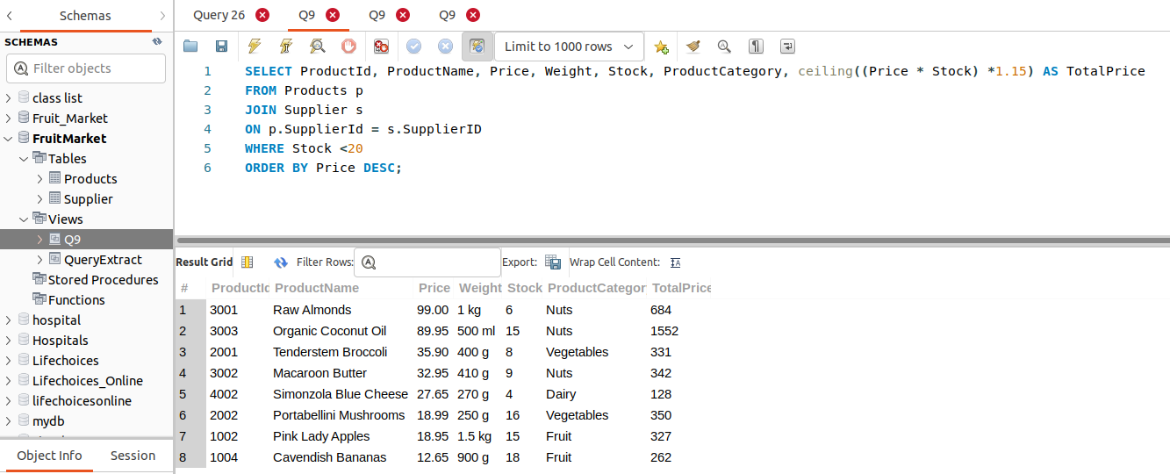

1 Mark for the view

1 Mark for the correct fields

3 marks for calculation of total price and ceiling

1 mark for correct records

Deduct a mark for incorrect tax calculation, total calculation

1.10 User called ‘yourname_initialofyoursurname’ with INSERT privileges on to the current database and and Supplier Table. Write your answer in the space provided [3]

CREATE USER 'manicia_t'@'localhost' IDENTIFIED BY 'M@nici@25';

GRANT INSERT ON FruitMarket.Supplier TO 'manicia_t'@'localhost';

1 mark for the correct user created

1 mark for the privileges

1 mark for correct database and table

1.11 Number of tables accessible. [1]

One only (Supplier)

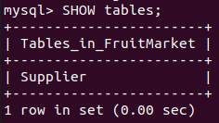

1.12 Add a record with the following details to the Suppliers table

('SUPP006', 'Fruit&Veg', 'Abdu', '0216965111', 'Nuts');

INSERT INTO Supplier (SupplierID, CompanyName, ContactPerson, ContactNo, ProductCategory) values ('SUPP0006', 'Fruit&Veg', 'Abdu', '0216965111','Nuts');

1 mark for correct SQL and record details

No mark if the output is wrong

1.13 Display all records in Suppliers table. [2]

No records can be displayed. The Select privilege has not been granted to the new user.

1 Mark for correct answer

1 Mark for reason

1.14 View called Q1.14 which will display ONLY the new user you created and the root. [2]

USE FruitMarket;

CREATE VIEW Q1,14 AS

SELECT User FROM mysql.user

WHERE User=’manicia_t’ OR User=’root’

1 Mark for correct view

1 Mark for correct condition

**1.15** SQL statement which produces the given records and permanently saved. Paste the code in the space provided below [3]

USE FruitMarket;

CREATE VIEW `Q1.15` AS

SELECT Products.ProductId, ProductName, Price, Weight, Stock, SupplierID

FROM Products

WHERE ProductId IN ('4002','3001','2001','3002','4001','1003','1001')

ORDER BY Products.Stock ASC;

1 view created

1 mark for correct Select statements

2 mark for correct condition

**1.16** SQL statement which produces the following output. Paste the code in the space provided. [3]

USE FruitMarket;

CREATE VIEW `Q1.16` AS

SELECT CompanyName, ContactNo, ProductName, Price

FROM Products

RIGHT JOIN Supplier

ON Products.SupplierID = Supplier.SupplierID;

1 Mark for creating view

1 Mark for correct fields [no mark for incorrect fields]

1 mark for the correct statement and correct records.

1.17 SQL code with output correctly formatted. [6]

USE FruitMarket;

CREATE VIEW `Q1.17` AS

SELECT sum(Price) AS Total_unit_price,

round((avg(Price)),2) AS Average_price,

count(ProductName) AS NumbeR_of_products

FROM `Q1.16`;

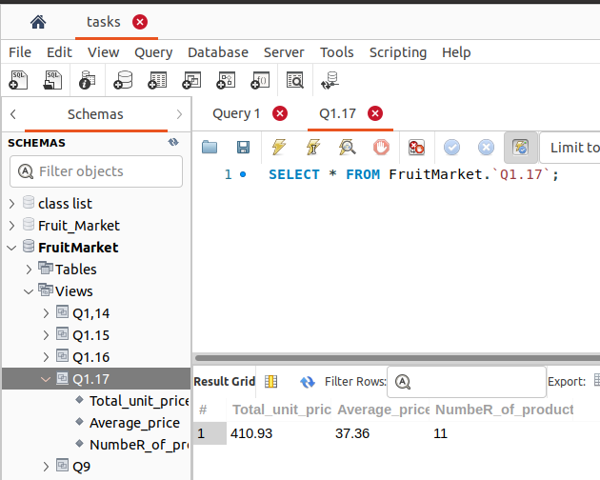

1 Mark for permanent SQL statement

3 marks for the correct functions.

1 marks for the headings

1 mark for formatting output

1.18 SQL statement to display the number of distinct supplierid from the products table. Add the SQL statement in the space provided.

[3]

USE FruitMarket;

CREATE VIEW `Q1.18` AS

SELECT count(distinct(SupplierID))

FROM Products;

1 Mark for creating a permanent sql statement

2 Mark for correct SQL statement producing correct output

[lecturer to award a mark if the statement is partially correct]

1.19 SQL statement to produce the following output as shown below. Make sure you save the output permanently as Q1.19.Add the SQL statement in the space provided. [4]

USE FruitMarket;

CREATE VIEW `Q1.19` AS

SELECT count(ProductId),SupplierID

FROM Products

GROUP BY SupplierID;

1 Mark for permanently saving the solution on to the databases

3 Marks for correct SQL producing correct output

1.20SQL Statement to produce a given output. Add the code in the space provided. [5]

CREATE VIEW `Q1.20` AS

SELECT count(ProductId),SupplierID,

SUM(Price*Stock) FROM FruitMarket.Products GROUP BY SupplierID;

1 Mark for saving output permanently

1 Mark for correct headings

2 Marks for correct functions

1 Mark for correct output

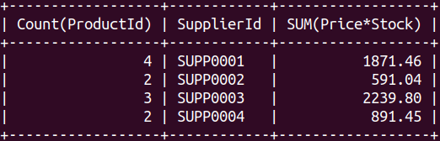

Make sure the result is visible in your database. Add the SQL statement in the space provided in the LMS.

1.21 SQL Statement to produce a given output. Add the code in the space provided. [2]

UPDATE Products

SET Price = '15.95', Weight = '1 kg', Stock = '18'

WHERE ProductId = '1004';

I mark for correct SQL command

1 Mark for correct output

1.22Create a database dump called FruitMarketYourname.sql and upload it into the LMS.[1]

1 Mark for database dump backup

**QUESTION 2 NORMALISATION (30 Marks)**

Consider the following unnormalised table.

|  |  |  |  |  |  |  |  |
| --- | --- | --- | --- | --- | --- | --- | --- |
| **User_ID** | **User_Name** | **MSE_ID** | **Rec_Date** | **Subject** | **Text** | **Srvr_ID** | **Server_Name** |
| 2301 | Smith | 54101 | 05/07 | Meeting Today | There is... | 3786 | IMAP05 |
| 2301 | Smith | 54098 | 07/12 | Promotions | I like to... | 3786 | IMAP05 |
| 2301 | Smith | 54445 | 10/06 | Next Assignment | Your next... | 3786 | IMAP05 |
| 5607 | Jones | 54101 | 05/07 | Meeting Today | There is... | 6001 | IMAP08 |
| 5607 | Jones | 54512 | 06/07 | Lunch? | Can you... | 6001 | IMAP08 |
| 5607 | Jones | 54660 | 12/01 | Jogging Today? | Can you... | 6001 | IMAP08 |
| 7773 | Walsh | 54101 | 05/07 | Meeting Today | There is... | 9988 | EMEA01 |
| 7773 | Walsh | 54554 | 03/17 | Stock Quote | The latest... | 9988 | EMEA01 |
| 0022 | Patel | 54101 | 05/07 | Meeting Today | There is... | 2201 | EMEA09 |
| 0022 | Patel | 54512 | 06/07 | Lunch? | Can we... | 2201 | EMEA09 |

Normalise the above table to Third Normal Form (3NF). Show all the tables

First Normal Form 2 tables (9 marks) 1 mark for each correct field.

Second Normal Form 3 Tables (10 Marks) 1mark for each correct field.

Third Normal Form 4 Tables (11 Marks) 1mark for each correct field.

Answers:

1st Normal Form

Table 1:

|  |  |  |  |
| --- | --- | --- | --- |
| **User_ID** | **User_Name** | **Srvr_ID** | **Server_Name** |
| 2301 | Smith | 3786 | IMAP05 |
| 5607 | Jones | 6001 | IMAP08 |
| 7773 | Walsh | 9988 | EMEA01 |
| 0022 | Patel | 2201 | EMEA09 |

Table 2:

|  |  |  |  |  |
| --- | --- | --- | --- | --- |
| **User_ID** | **MSE_ID** | **Rec_Date** | **Subject** | **Text** |
| 2301 | 54101 | 05/07 | Meeting Today | There is... |
| 2301 | 54098 | 07/12 | Promotions | I like to... |
| 2301 | 54445 | 10/06 | Next Assignment | Your next... |
| 5607 | 54101 | 05/07 | Meeting Today | There is... |
| 5607 | 54512 | 06/07 | Lunch? | Can you... |
| 5607 | 54660 | 12/01 | Jogging Today? | Can you... |
| 7773 | 54101 | 05/07 | Meeting Today? | There is... |
| 7773 | 54554 | 03/17 | Stock Quote | The latest... |
| 0022 | 54101 | 05/07 | Meeting Today | There is... |
| 0022 | 54512 | 06/07 | Lunch? | Can we... |

2nd Normal Form

Table 1:

|  |  |  |  |
| --- | --- | --- | --- |
| **User_ID** | **User_Name** | **Srvr_ID** | **Server_Name** |
| 2301 | Smith | 3786 | IMAP05 |
| 5607 | Jones | 6001 | IMAP08 |
| 7773 | Walsh | 9988 | EMEA01 |
| 0022 | Patel | 2201 | EMEA09 |

Table 2:

|  |  |  |
| --- | --- | --- |
| **User_ID** | **MSE_ID** | **Rec_Date** |
| 2301 | 54101 | 05/07 |
| 2301 | 54098 | 07/12 |
| 2301 | 54445 | 10/06 |
| 5607 | 54101 | 05/07 |
| 5607 | 54512 | 06/07 |
| 5607 | 54660 | 12/01 |
| 7773 | 54101 | 05/07 |
| 7773 | 54554 | 03/17 |
| 0022 | 54101 | 05/07 |
| 0022 | 54512 | 06/07 |

Table 3:

|  |  |  |
| --- | --- | --- |
| **MSE_ID** | **Subject** | **Text** |
| 54101 | Meeting Today | There is... |
| 54098 | Promotions | I like to... |
| 54445 | Next Assignment | Your next... |
| 54512 | Lunch? | Can you... |
| 54660 | Jogging Today? | Can you... |
| 54554 | Stock Quote | The latest... |

3rd Normal Form

Table 1:

|  |  |
| --- | --- |
| **User_ID** | **User_Name** |
| 2301 | Smith |
| 5607 | Jones |
| 7773 | Walsh |
| 0022 | Patel |

Table 2:

|  |  |  |
| --- | --- | --- |
| **User_ID** | **Srvr_ID** | **Server_Name** |
| 2301 | 3786 | IMAP05 |
| 5607 | 6001 | IMAP08 |
| 7773 | 9988 | EMEA01 |
| 0022 | 2201 | EMEA09 |

Table 3:

|  |  |  |
| --- | --- | --- |
| **User_ID** | **MSE_ID** | **Rec_Date** |
| 2301 | 54101 | 05/07 |
| 2301 | 54098 | 07/12 |
| 2301 | 54445 | 10/06 |
| 5607 | 54101 | 05/07 |
| 5607 | 54512 | 06/07 |
| 5607 | 54660 | 12/01 |
| 7773 | 54101 | 05/07 |
| 7773 | 54554 | 03/17 |
| 0022 | 54101 | 05/07 |
| 0022 | 5412 | 06/07 |

Table 4:

|  |  |  |
| --- | --- | --- |
| MSE_ID | Subject | Text |
| 54101 | Meeting Today | There is... |
| 54098 | Promotions | I like to... |
| 54445 | Next Assignment | Your next... |
| 54512 | Lunch? | Can you... |
| 54660 | Jogging Today? | Can you... |
| 54554 | Stock Quote | The latest... |

*...The End...*